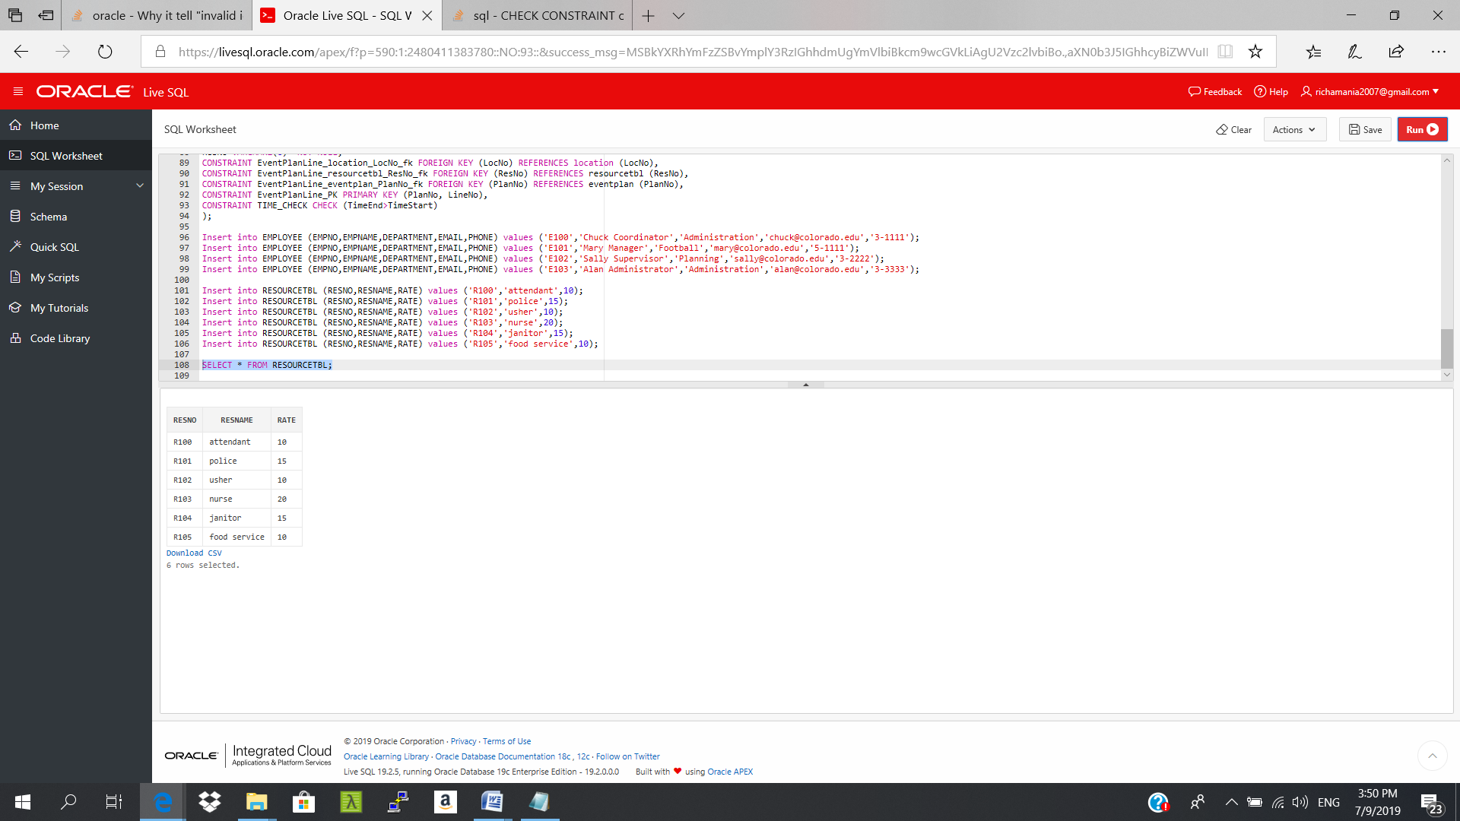USING ORACLE

QUESTION2)

CREATE TABLE ResourceTbl

(

ResNo VARCHAR2(4),

ResName VARCHAR2(20) NOT NULL,

Rate INTEGER NOT NULL,

CONSTRAINT PK_RESNO PRIMARY KEY (ResNo)

);